

American International University-Bangladesh

CSC 3215: Web Technologies

CO1.1 and CO2.1 Evaluation

Project Report

Fall 2022-23

Project Title: Hospital Mangement System (HMS)

Section: I

Group No: 06

|  |  |
| --- | --- |
| Student Name | Student Id |
| Shadril Hassan Shifat | 20-42451-1 |
| Gourob Kumar Das | 20-42482-1 |
| Ummee Zinat Refaiat | 20-42487-1 |
| Md. Sadi Amin | 20-42453-1 |

Introduction:

Every citizen has to visit a doctor many times in their entire life. And the process of getting an appointment to meet the doctor and perform the tests is very time consuming and problematic due to different issues. The citizen has to book an appointment manually and then wait for his meeting time for a considerable period. When a citizen visits a doctor and the doctor prescribes him medicine or test, the data is stored on a hard paper, which can easily be lost or broken.

And the consequence of this is to re-visit the doctor or re-test the following tests that are a hassle and costly. A digital web-based system is capable of eliminating these complexities simultaneously will save both time and money.

Background Study

Reference: [*https://www.bdtask.com/hospital-management-system.php*](https://www.bdtask.com/hospital-management-system.php)

With our application, users can easily book doctor’s appointment. The prescription and other details will be stored in database. Doctor can send notification to patients, also can monitor patients' health condition with the data given by patients. With this application, a user can book ambulance online, can find blood donors and also buy medicine from the hospital online. In our proposed application, admin will manage doctor, pharmacist and user.

Requirement Analysis:

1. User Category:

There are n-types of Users here. They are:

* Admin
* Doctor
* Patient
* Pharmacist

1. Feature List:

In this project the “Admin” has the following features:

* Login
* Sign-up
* Update Profile
* Forgot Password
* Change Password
* View Profile
* Add Blood Donor
* Manage doctor
* Manage patient
* Manage Pharmacist

In this project the “Doctor” has the following features:

* Login
* Sign-up
* Update Profile
* Forgot Password
* Change Password
* Prescribe Medicine
* Add appointment
* Delete appointment
* View Profile

In this project the “Patient” has the following features:

* Login
* Sign-up
* Update Profile
* Forgot Password
* Change Password
* View Profile
* Book Appointment
* Book Ambulance
* See blood donors
* Order Medicine

In this project the “Pharmacist” has the following features:

* Login
* Sign-up
* Update Profile
* Forgot Password
* Change Password
* View Profile
* Add Medicine
* Update Medicine
* Delete Medicine
* View prescription

Design:

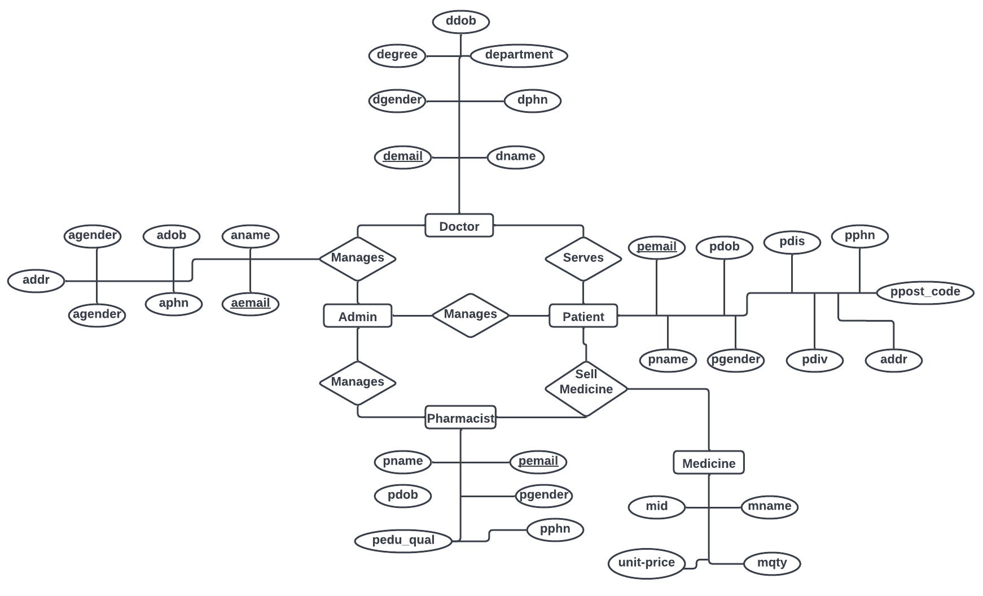

Entity Diagram of HMS

Tools Used:

To develop this project, we have used the following:

• Xampp

• Visual Studio Code

• Sublime Text

• Google Chrome

System Images against the Specification:

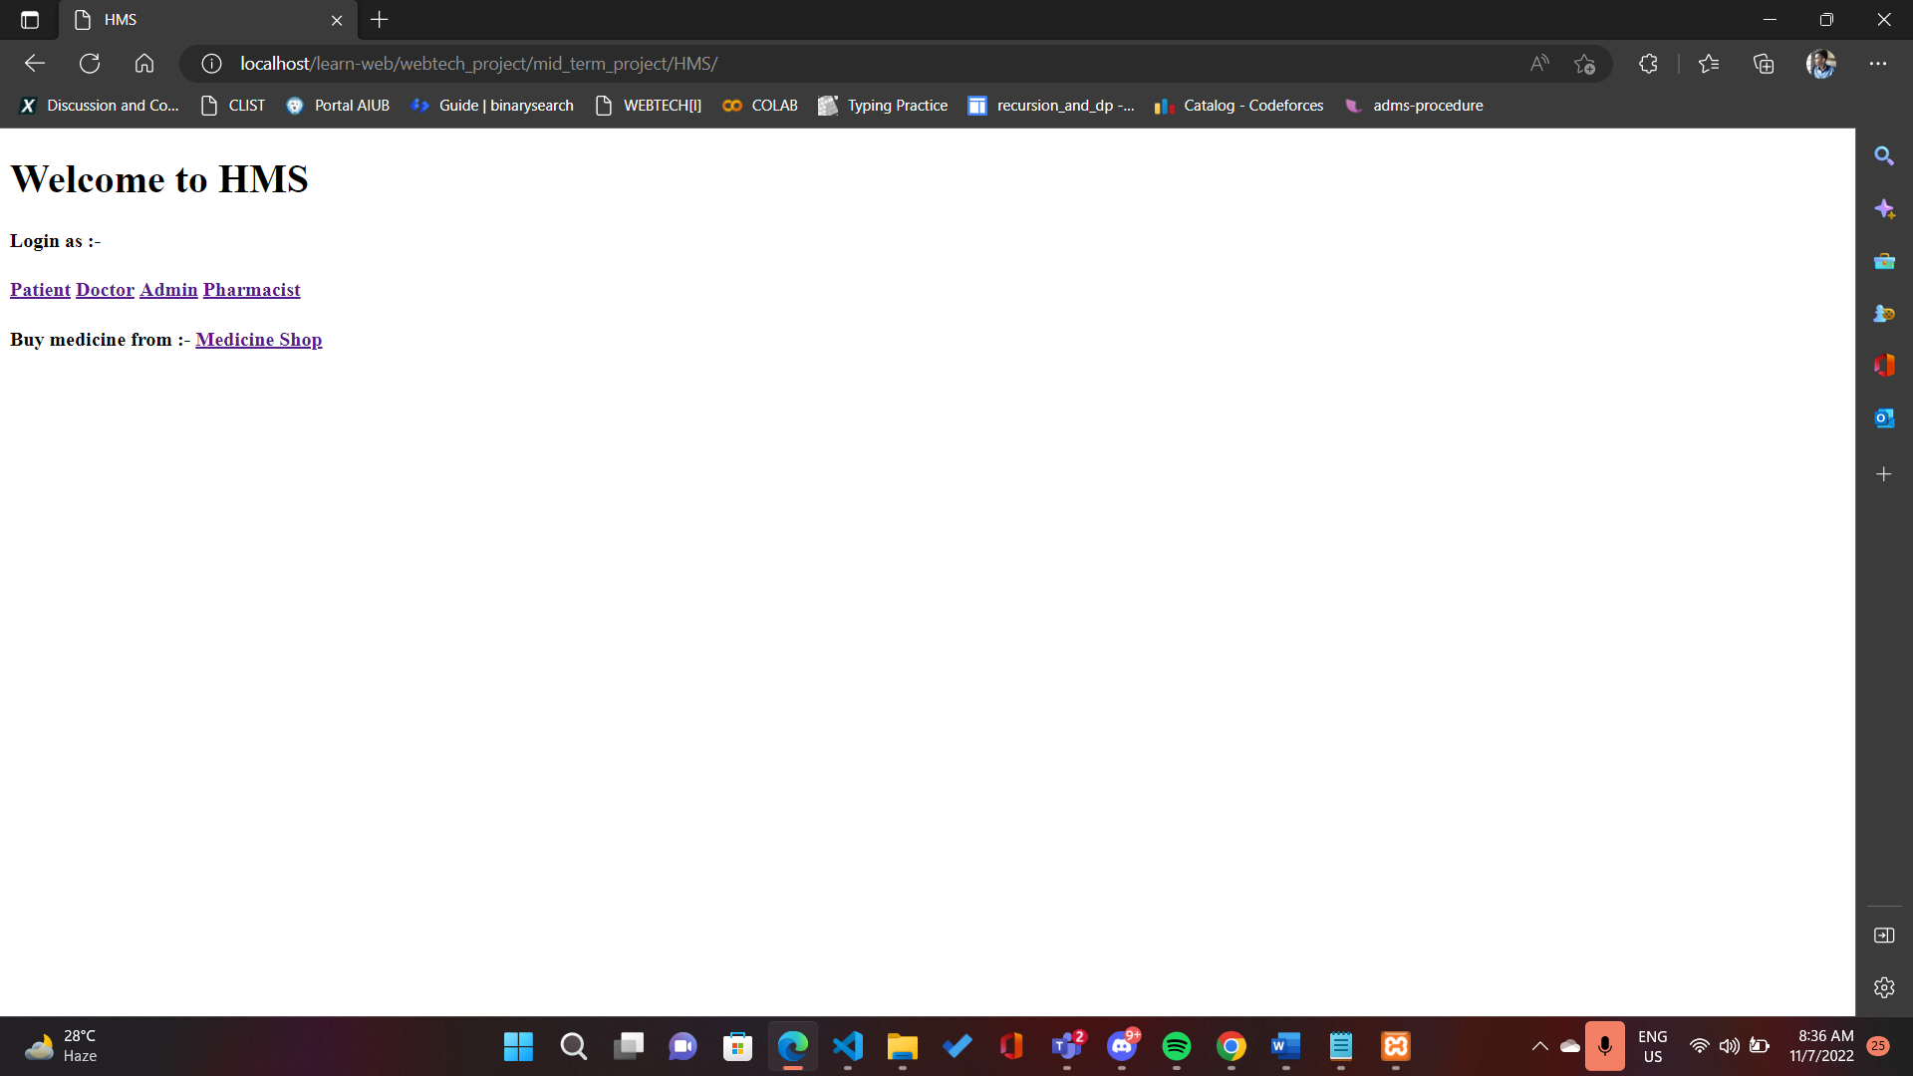

This is the home page of our HMS project. From this page, a user can access their profiles.

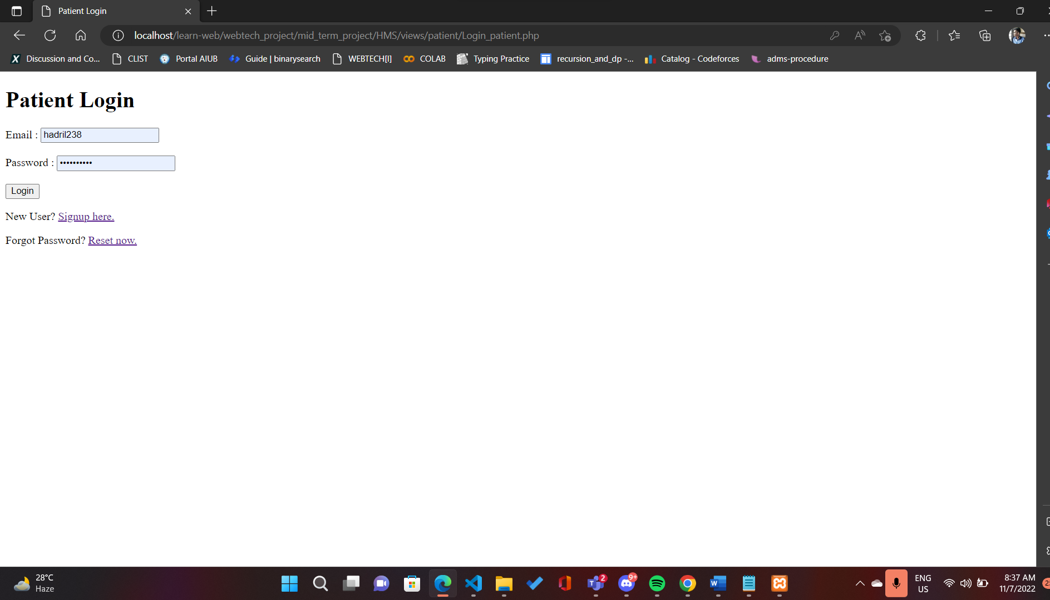

This is the patient login page. From this page, a patient can login to their account or profile.

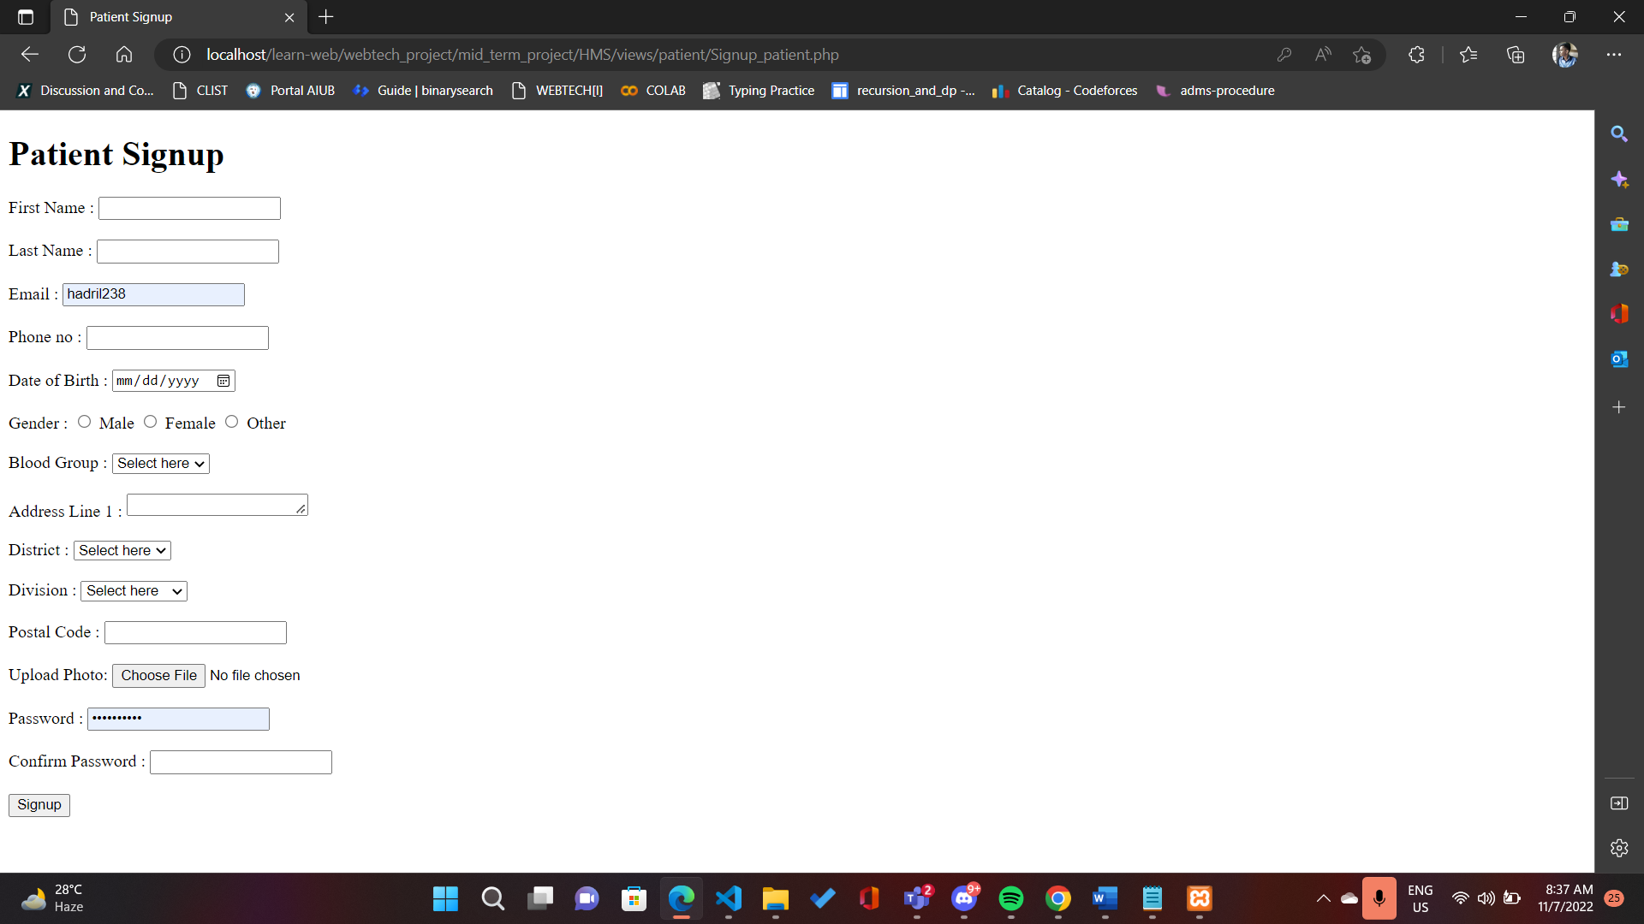

This is the patient Sign-up page. From this page, a patient can create new account by providing their personal details.

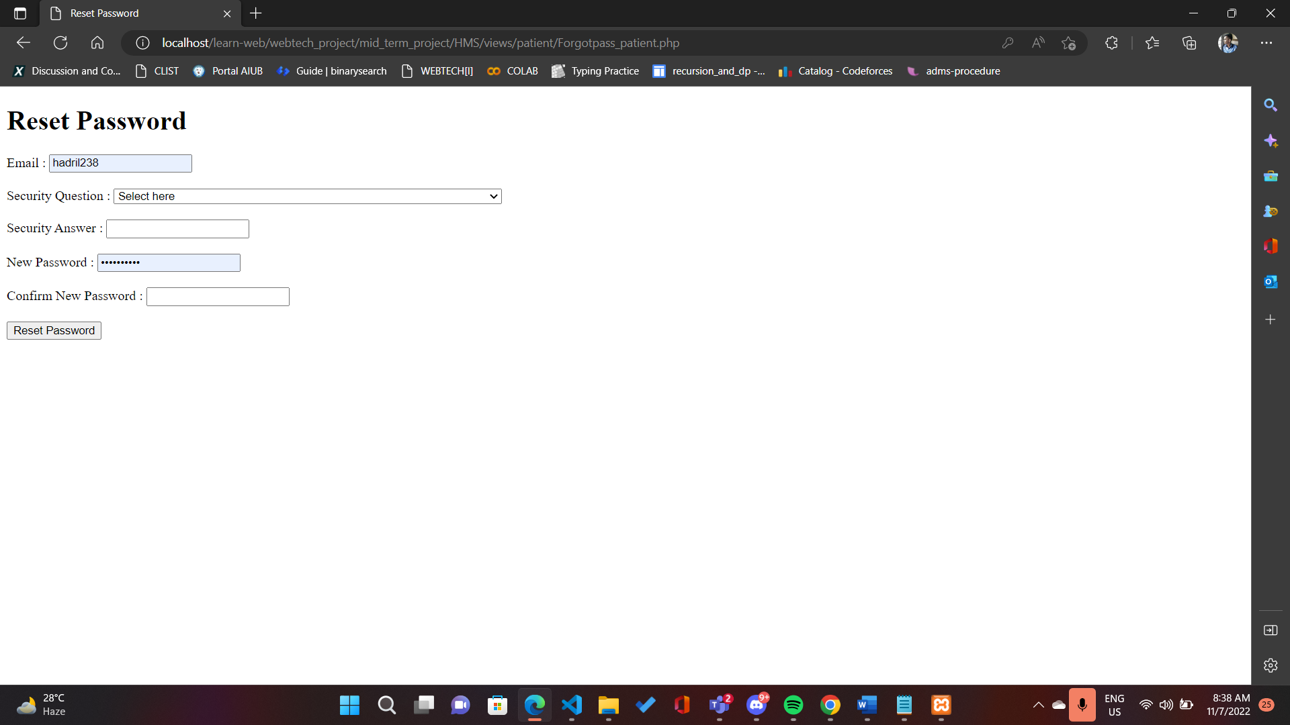

This is the reset password page. A patient can reset their password

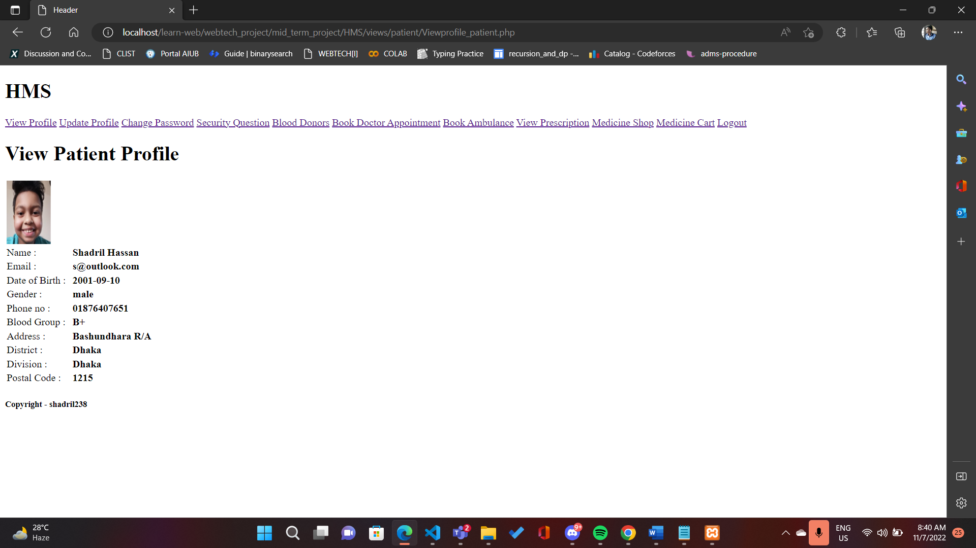

This is the patient profile page. In this page, a patient can see their profile

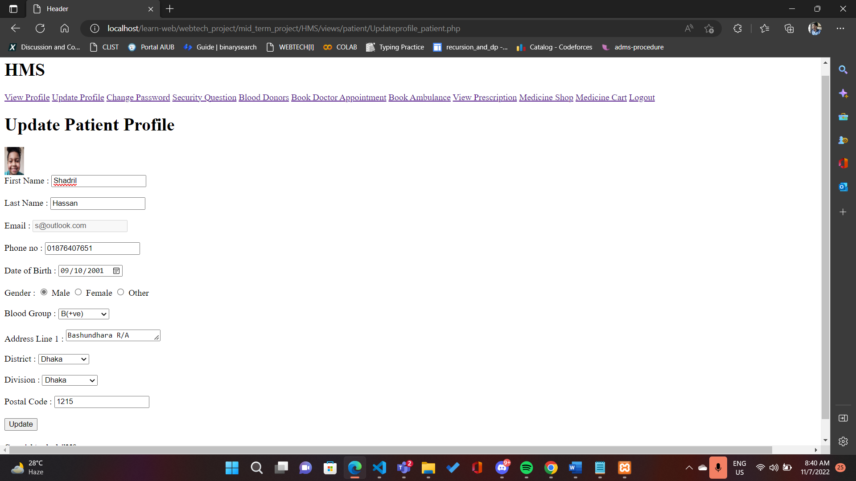

This is the patient Update profile page. In this page, a patient can update their personal information.

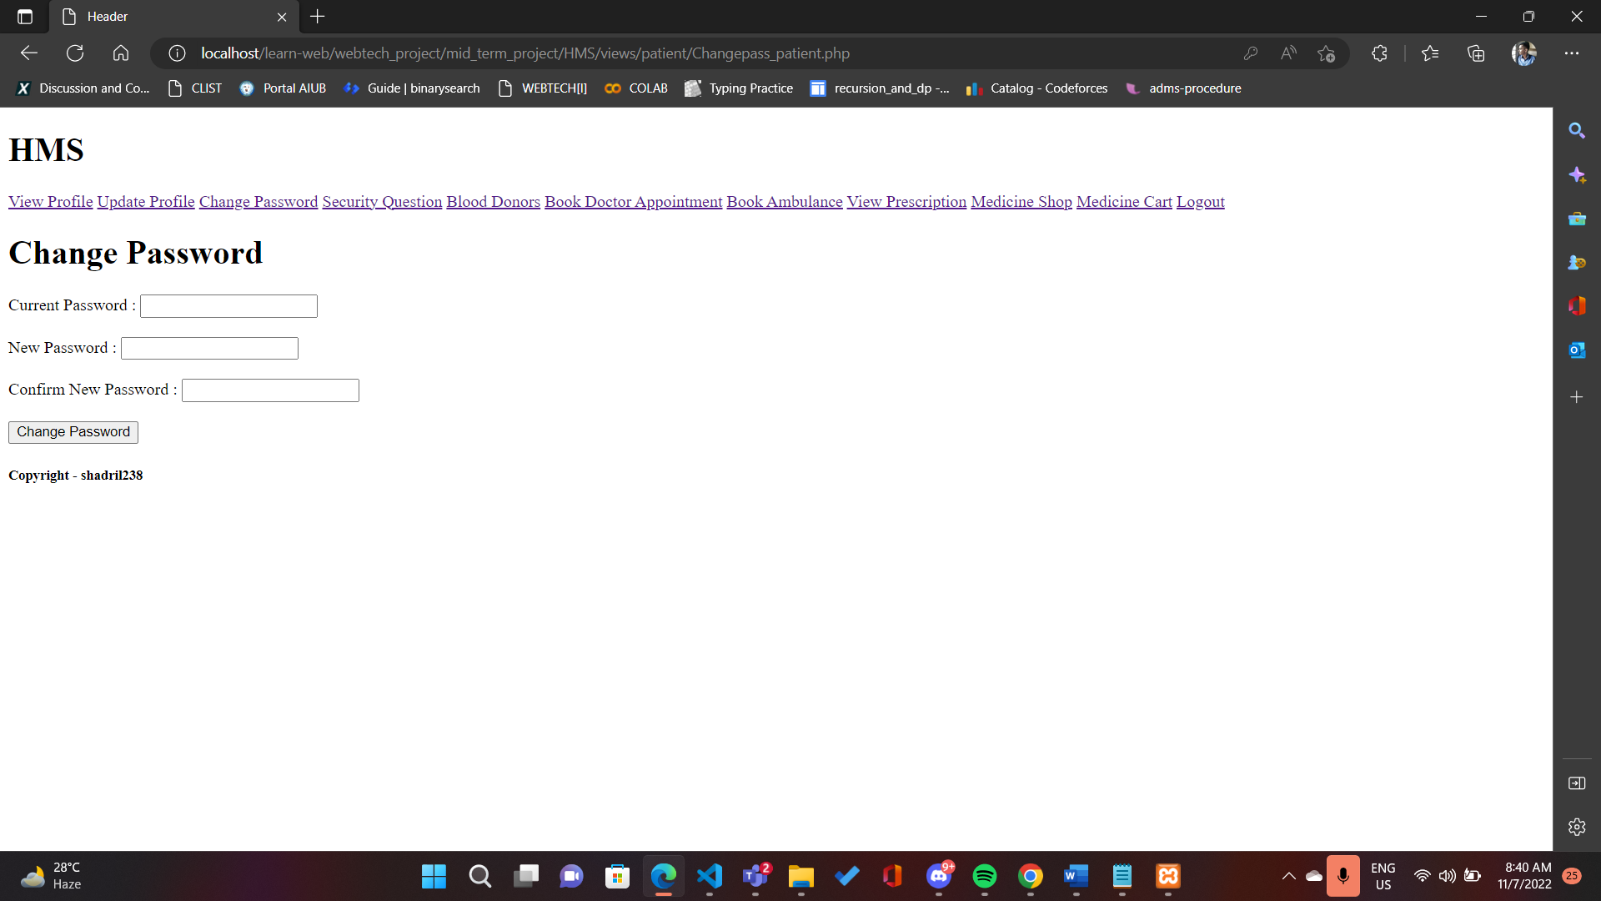

This is the patient change password page. In this page, a patient can change their password.

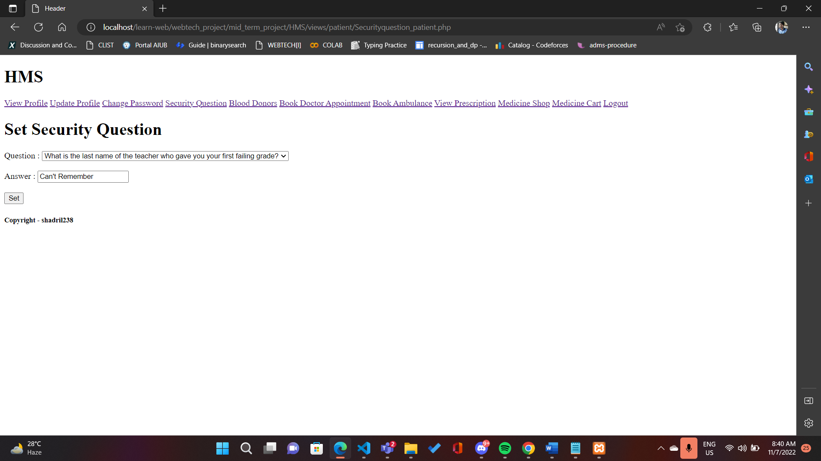

This is the patient security question page. In this page, a patient can set their security questions and answers so that they can use it when changing their password.

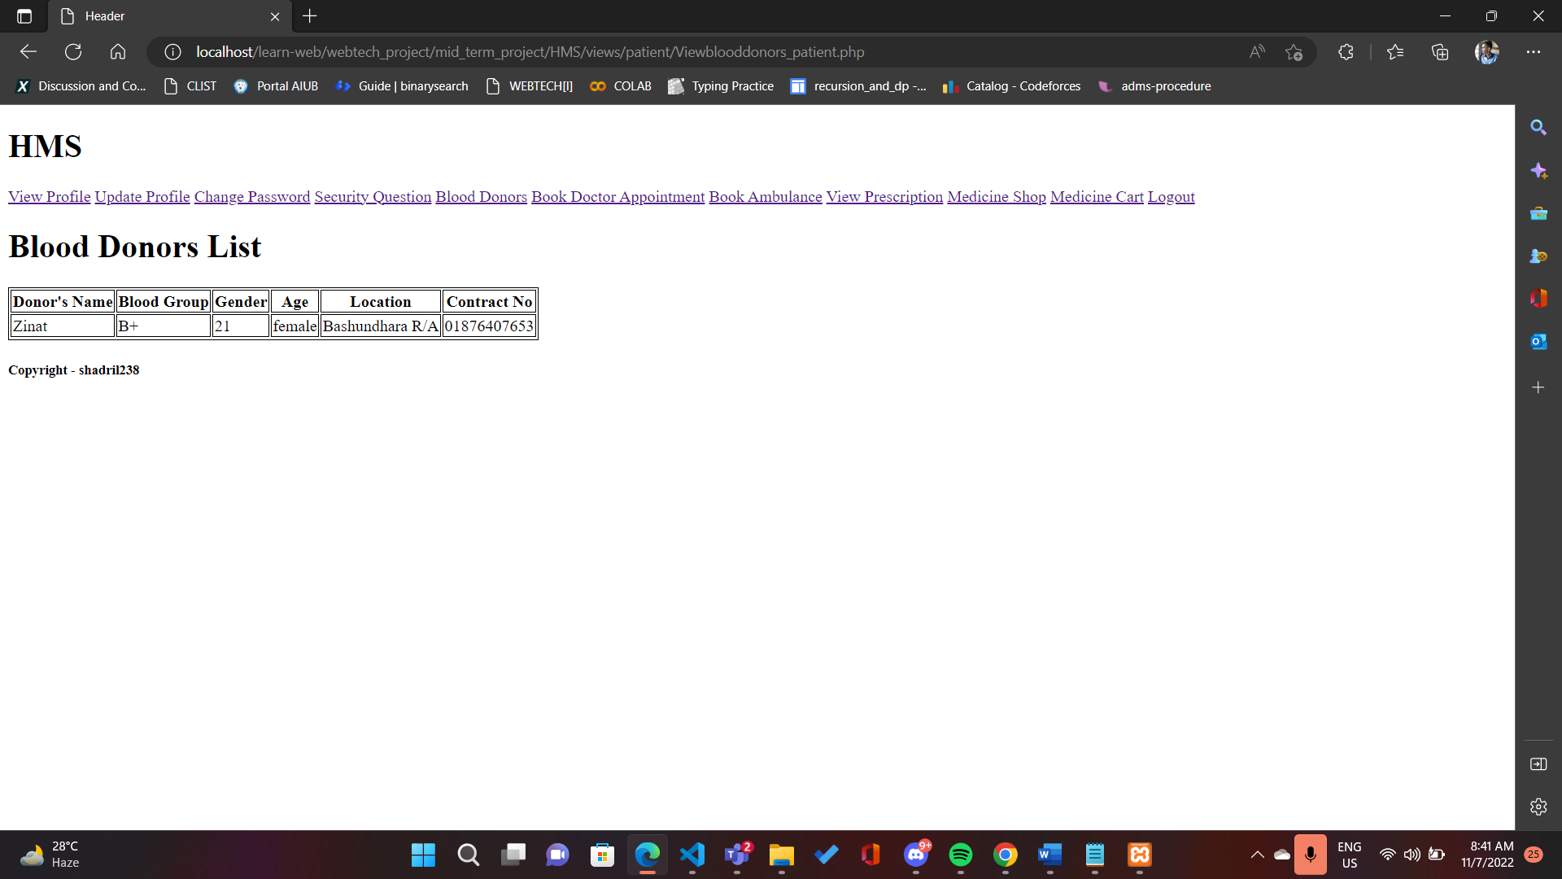

This is the Blood donor list page. In this page, particular blood donor lists can be seen.

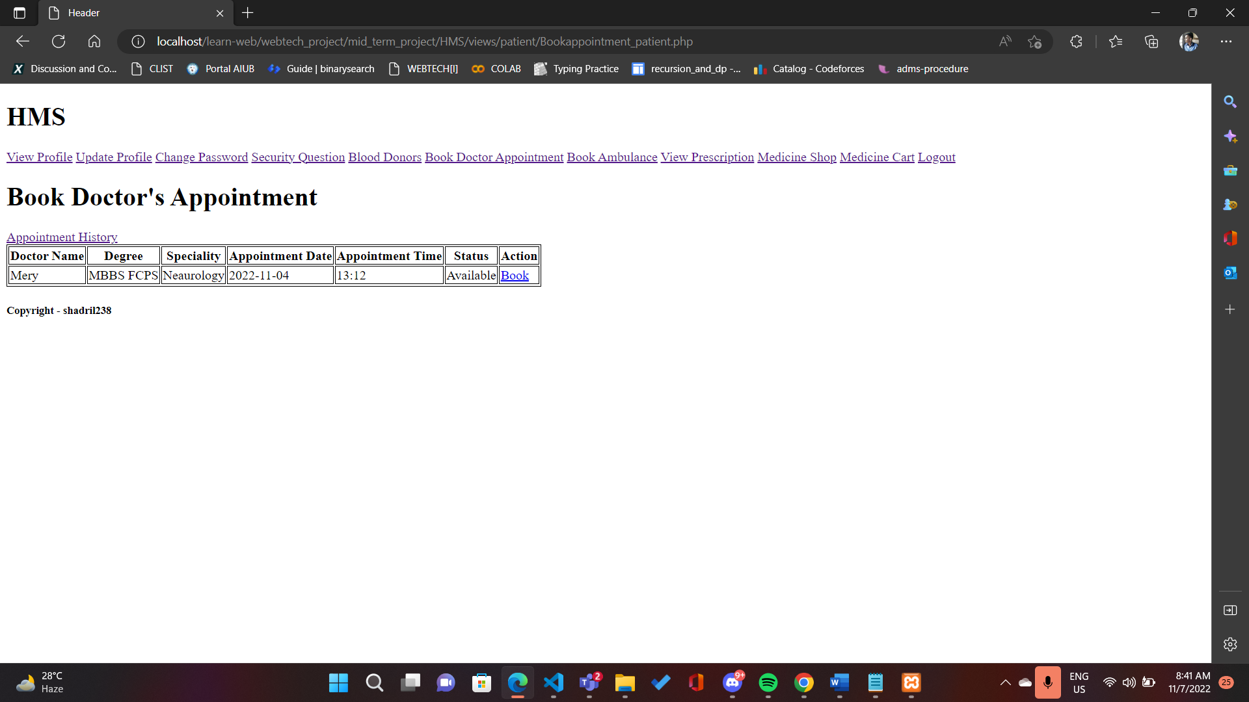

Here, the user can find doctors and book appointments.

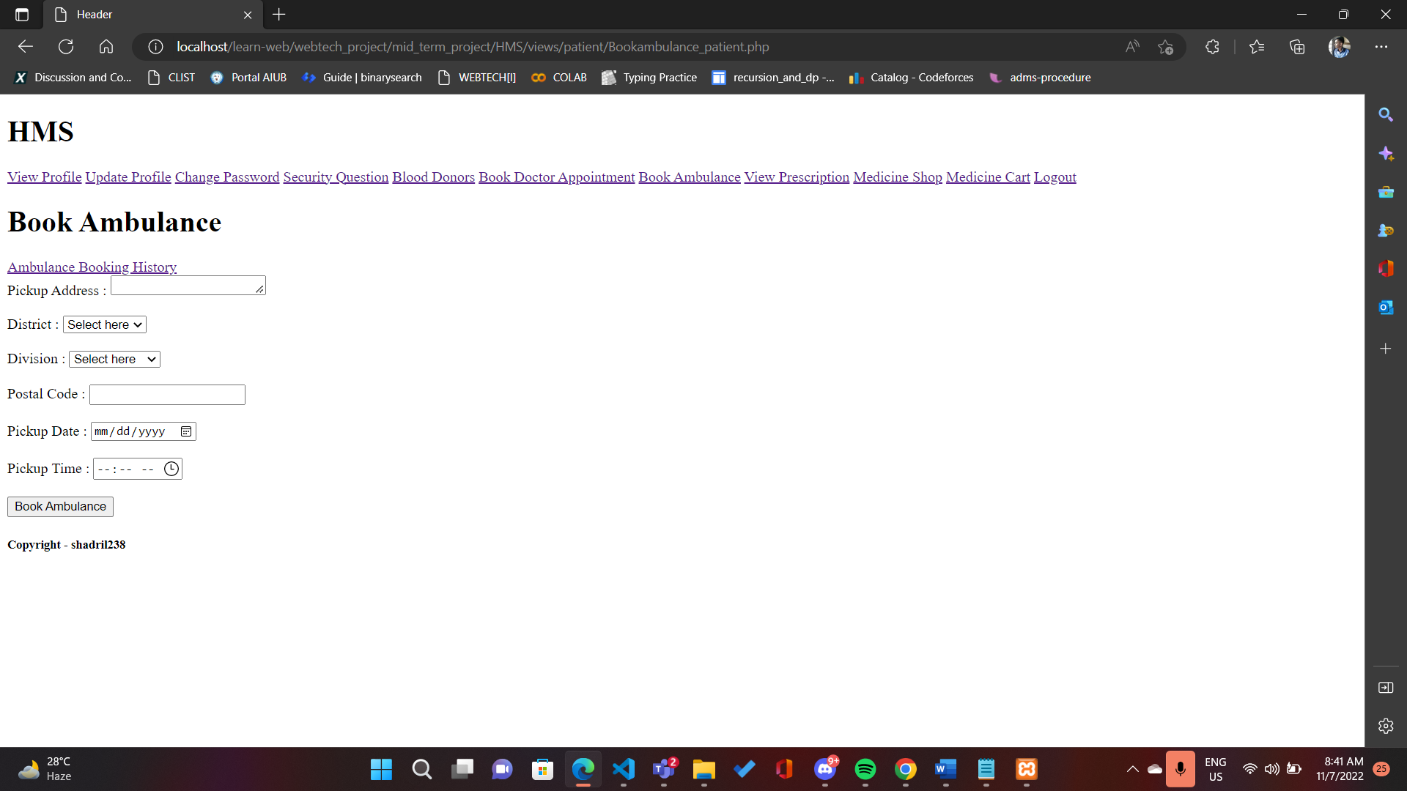

Here, the users can book an ambulance.

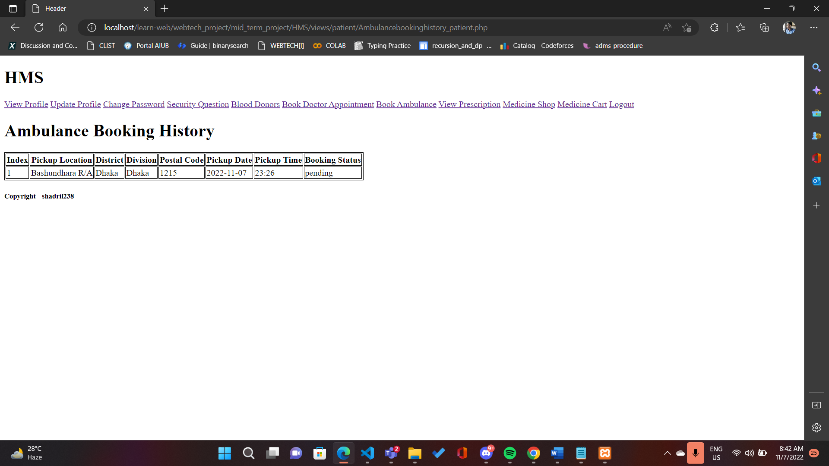

Here, the users can see their ambulance booking history.

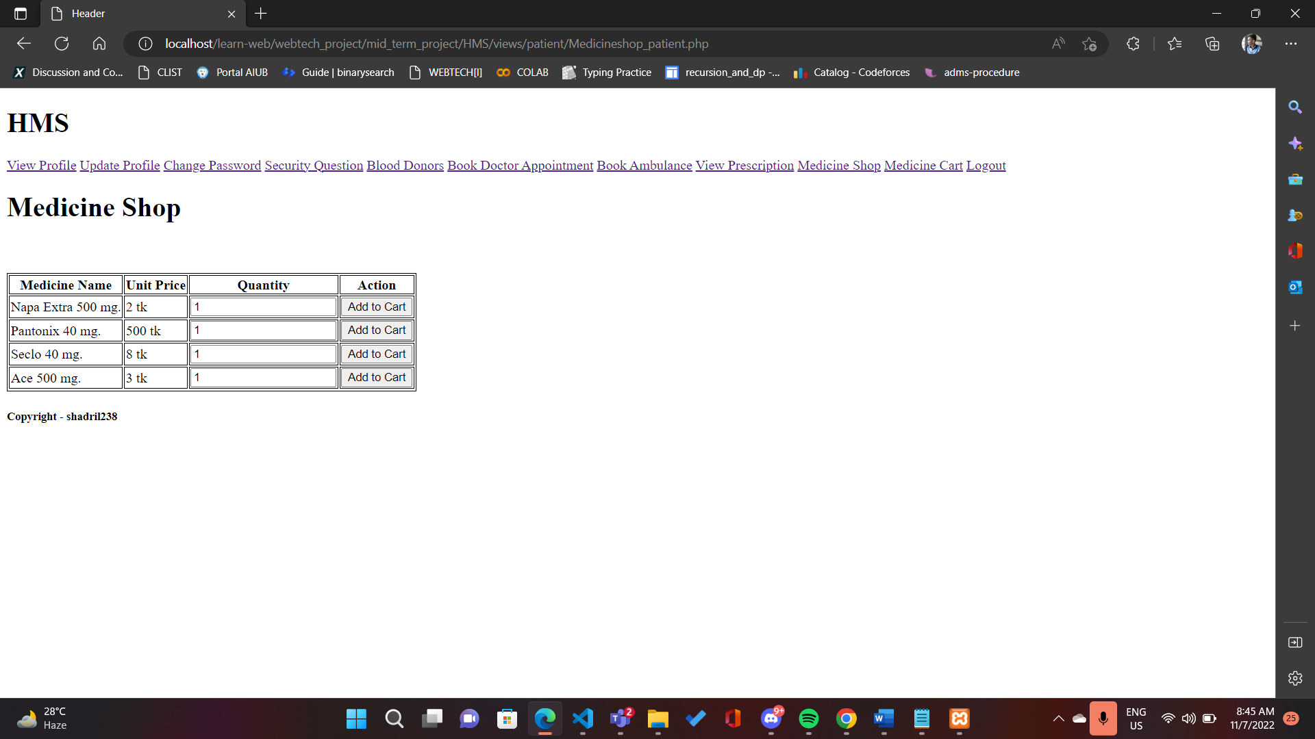

Here, the users can add medicines/products to cart.

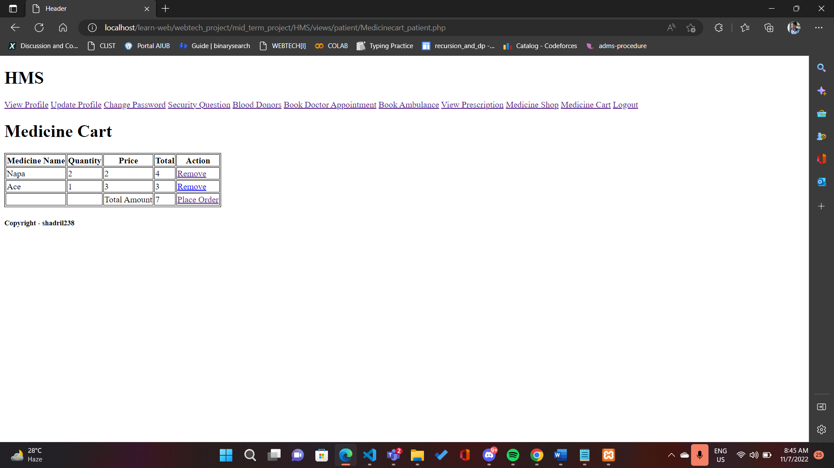

Here, the users can view carts for placing order. Also, the users can remove medicine from cart.

Impact of this Project:

HMS provides the ability to manage all the paperwork in one place, reducing the work of staff in arranging and analyzing the paperwork of the patients. HMS does many works like:

* Maintain the medical records of the patient
* Maintain the contact details of the patient
* Keep track of the appointment dates
* Appointment management
* Prescription management.
* Time-saving Technology
* Improved Efficiency by avoiding human errors
* Reduces scope for Error
* Data security and correct data retrieval made possible
* Cost effective and easily manageable
* Easy access to patient data with correct patient history
* Reduces the work of documentation

Limitations and Possible Future Improvements:

There are certain limitations in our project. The doctor can view patient details through our project or software, but they can’t talk to each-other or live chat with each other. In our project, we also didn’t use any designs. So, in future the live-chat feature can be added and also new designs can be implemented for better view of the software.

*[Note: Make sure that your report is maximum 10 pages (including cover page). Print (Colored) the report and submit it with spiral bind.]*

|  |  |  |  |  |  |
| --- | --- | --- | --- | --- | --- |
| CO1.1 and CO2.1 Evaluation: Project Report Evaluation | | | | | |
| Project Proposal  (5) | Background  Study  (5) | Requirement Analysis  (5) | Entity  Diagram  (5) | System Images  against the  Specification (5) | Total (25) |
|  |  |  |  |  |  |
|  | | | | | |